<img src="./image 3.jpg" alt="This is image"/>

    <a href="https://www.google.com/" target="_blank">click here to go google</a>

**Github Login Credentials**

**Email id and P/w-Mahira@2022**

**Username:** **Studd-Developer**

Meta will be under head tag. Used for SEO. There is fixed tag for every meta tag

<meta charset=”UTF-8”>

>meta=”description” content=”free web tutorials”>

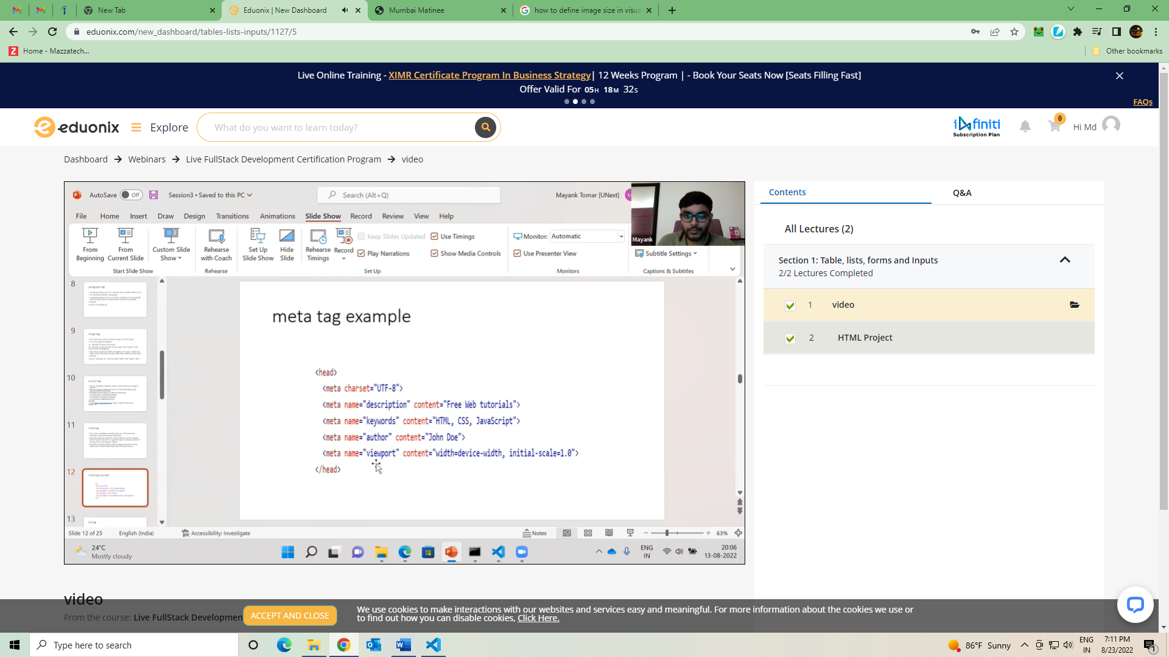

H1-heading- Restrua Name

Paragraph in larger size (5-8 lines)

Then 3 image of Restrau

Then one link in bottom

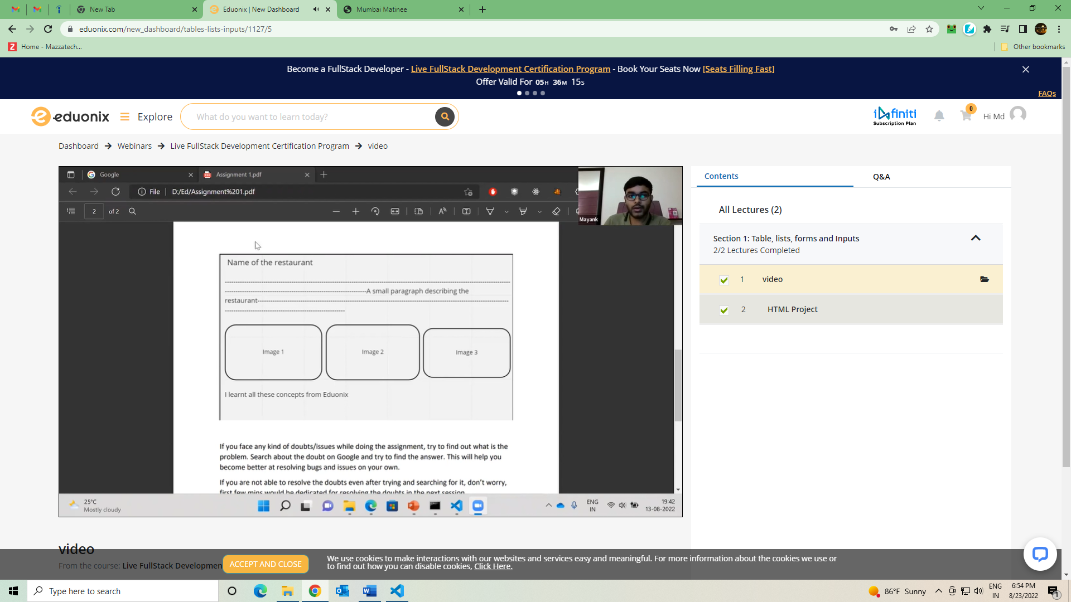

List Tag

Unordered Item and List items

<ol> and <li> and <ul>

<ul>

<li> First name <li> and so on

<ul>

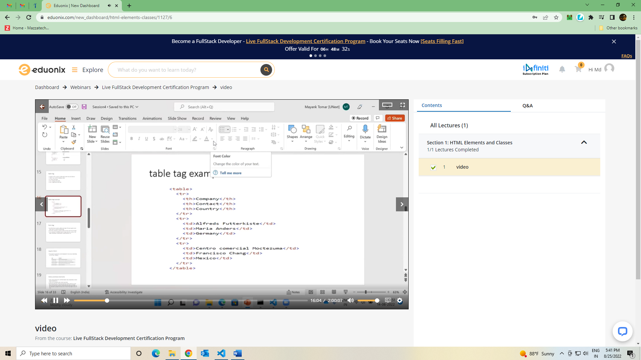

Table Tag

Row- <tr>

Cell <td>

<td>- heading

Form Tag, Br Tag means for next line. <Div> is for division

Span Tag is used as a inline in Paragraph where we can get the option to change the properties of that line. Can be use for styling

Class and ID mainly use in JavaScript and CSS

HTML Entity.. Some character are reserved by HTML. So, if we want to you special character, then use below.

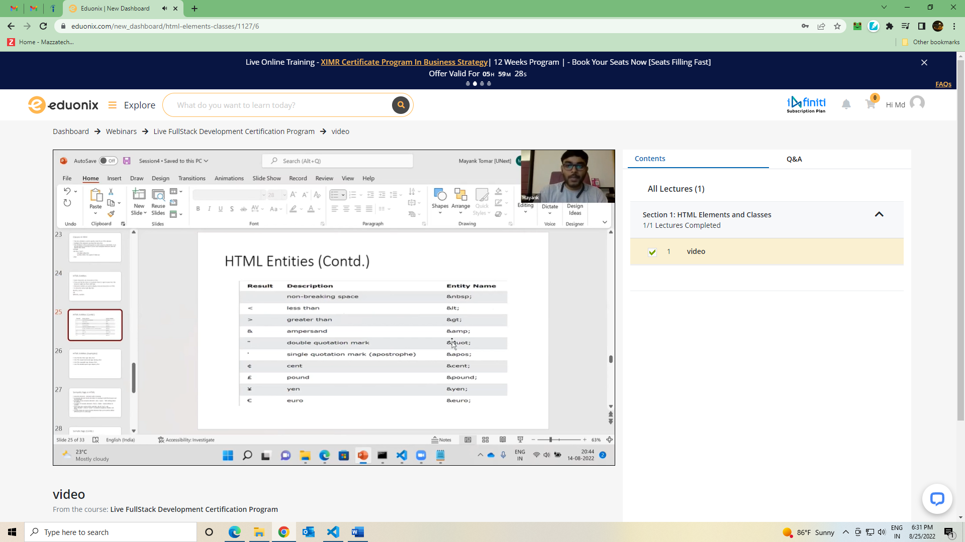 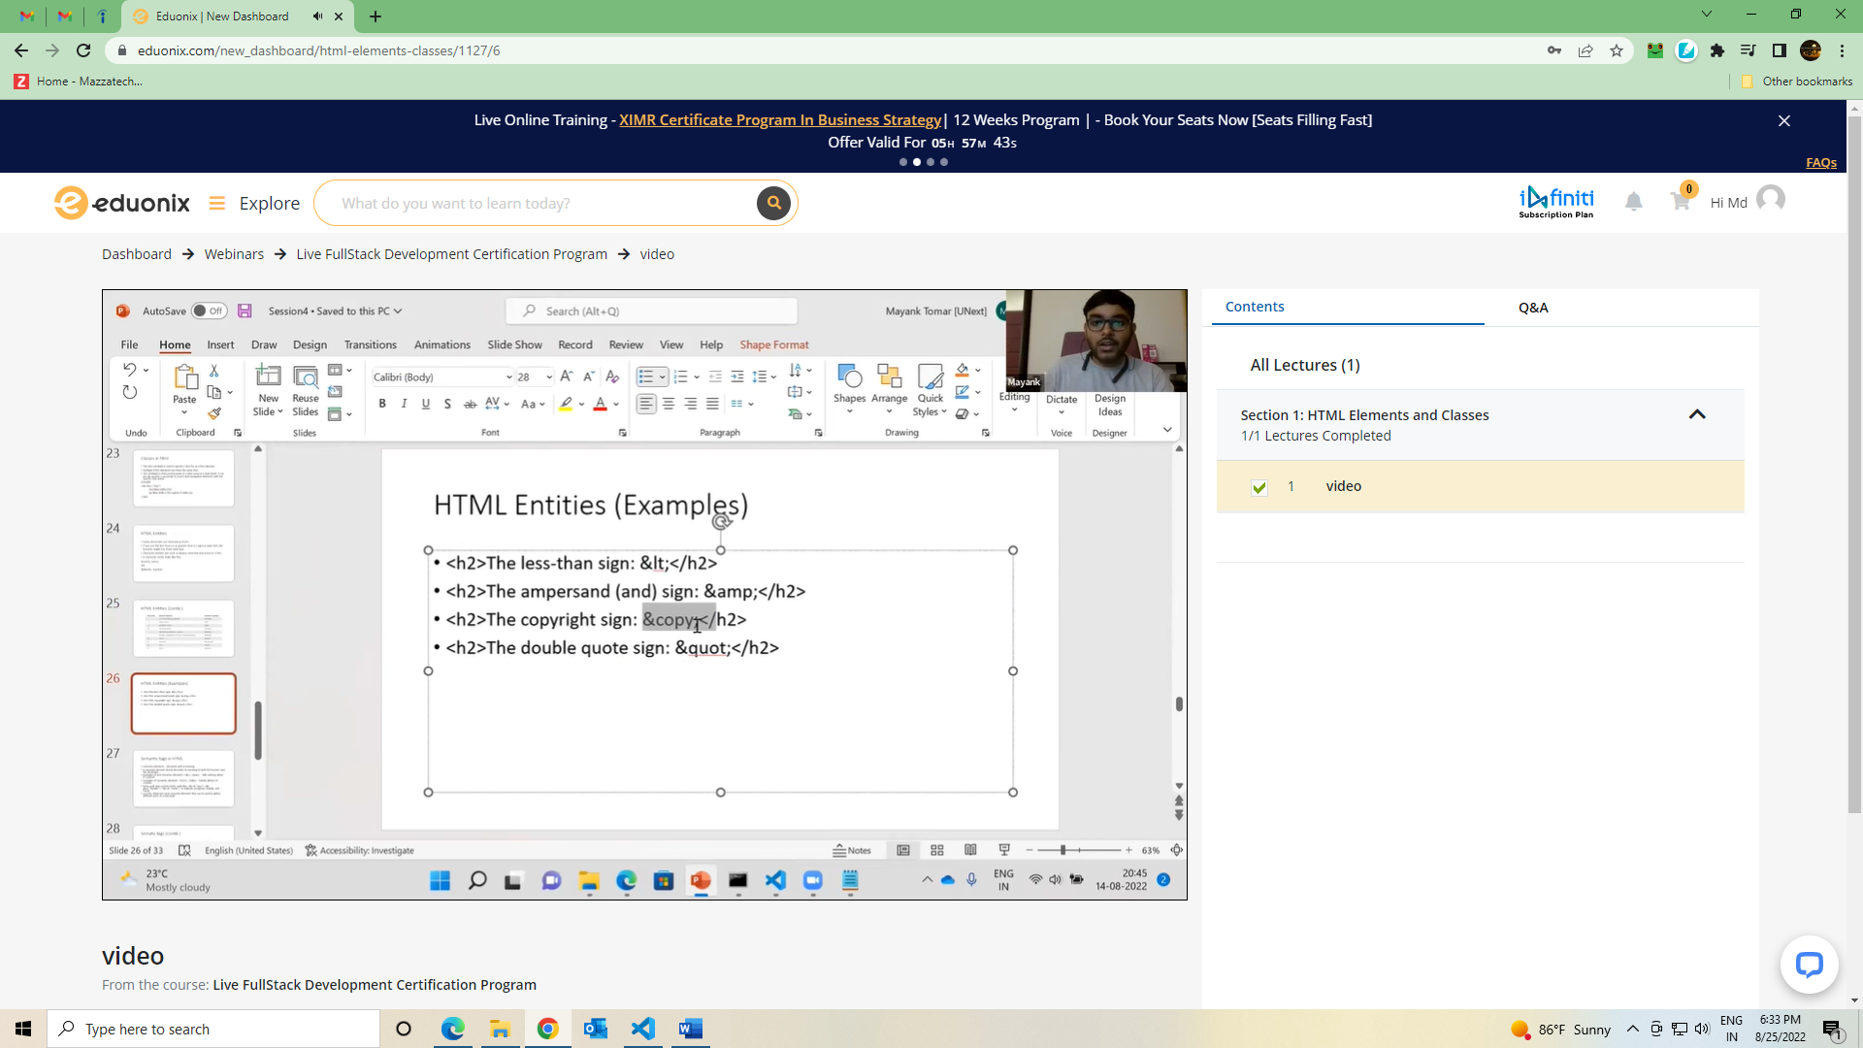

Sematic Tag= which clearly defines its content. Ex. Table tag, form tag. It help other to read your code. And can be good for seo.

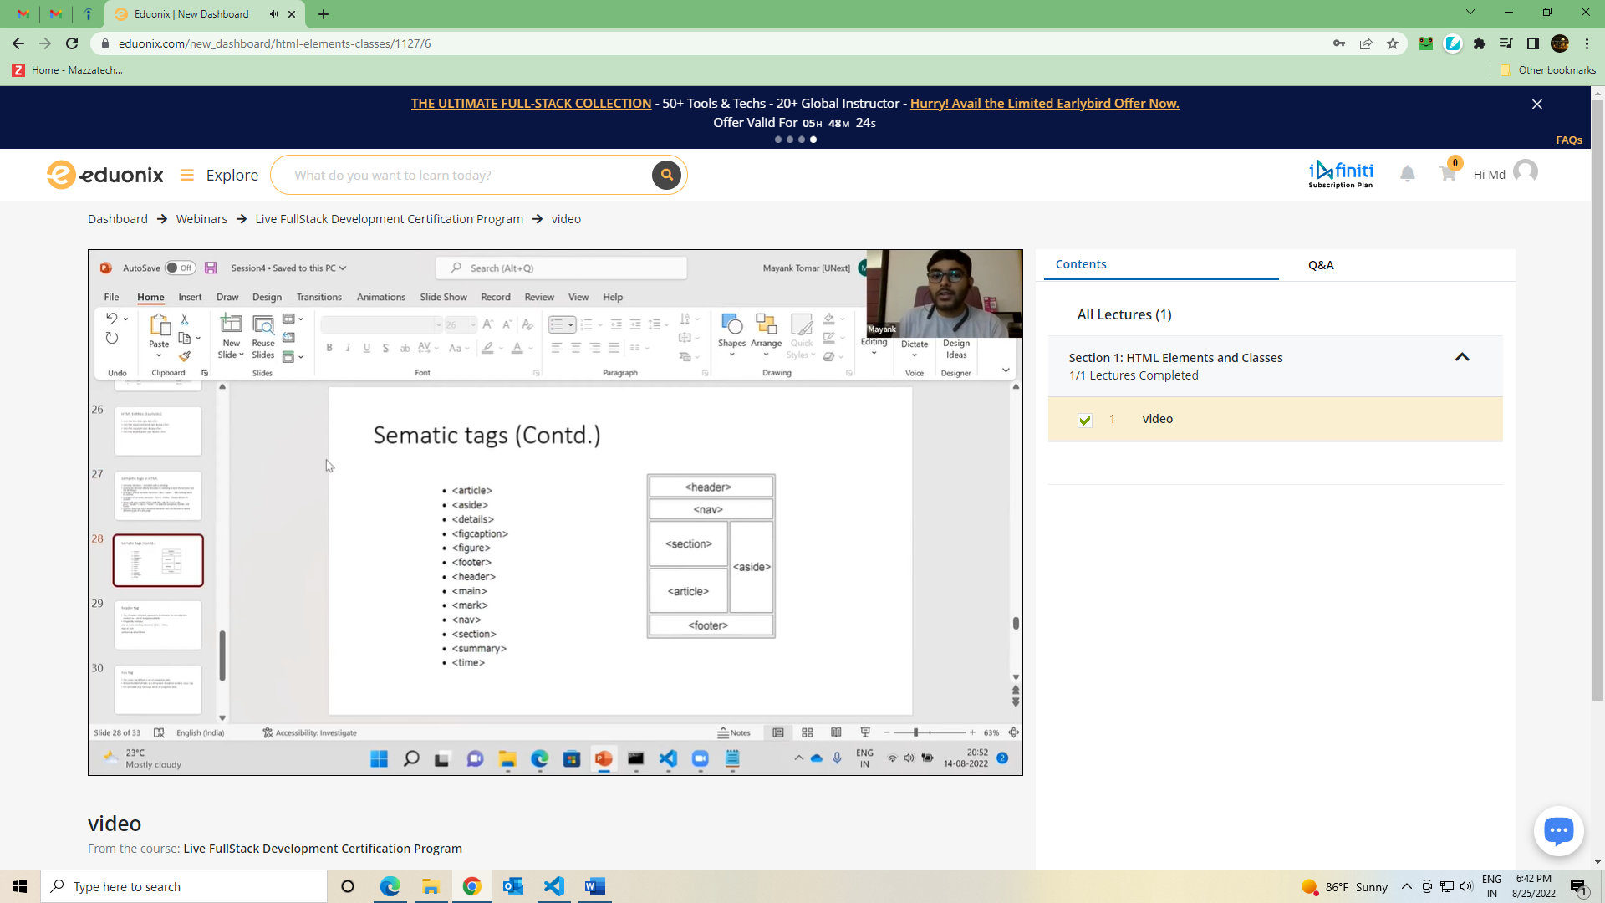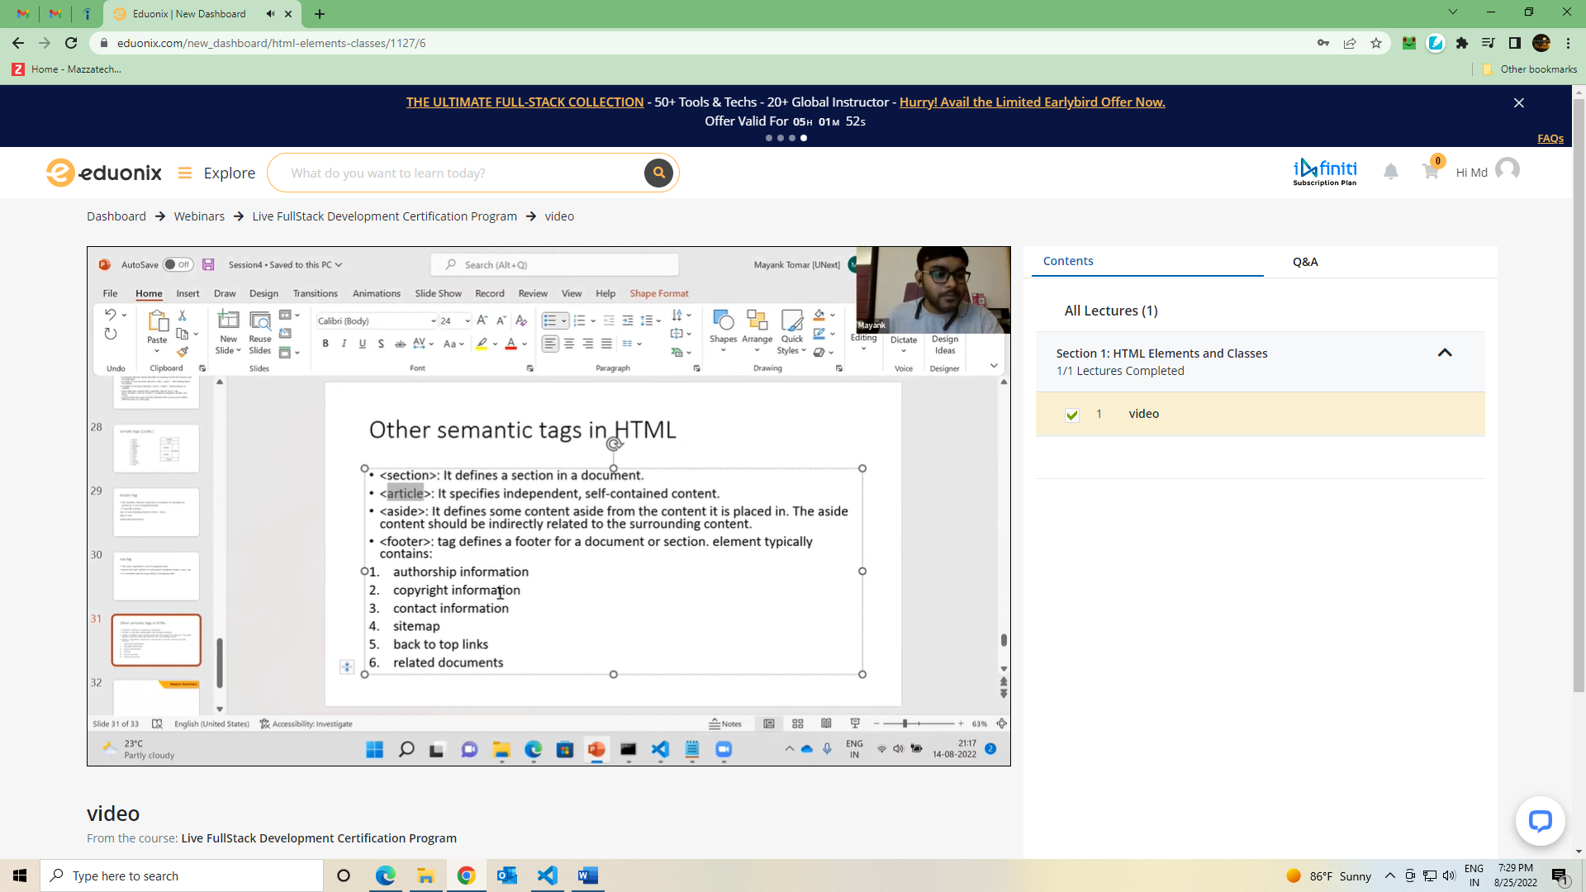

**First Assignment is Portfolio about ourself**

[**https://livecodestream.dev/post/git-concepts-and-workflow-for-beginners/-**](https://livecodestream.dev/post/git-concepts-and-workflow-for-beginners/-) **Article about Github**

**CSS**

